**Proposal – Project 2**

Team Members - Tanja Nyberg, Haiyan Richter, Meliza Abanilla

Topic: We will be focusing on major airports and airlines performance in the United States.

Potential Data Sources: <https://ntl.bts.gov/>

<https://www.transportation.gov/policy/aviation-policy/>

Inspiration/Idea: <https://cse442-17s.github.io/Airline-Performance-In-US/final/#Cover>

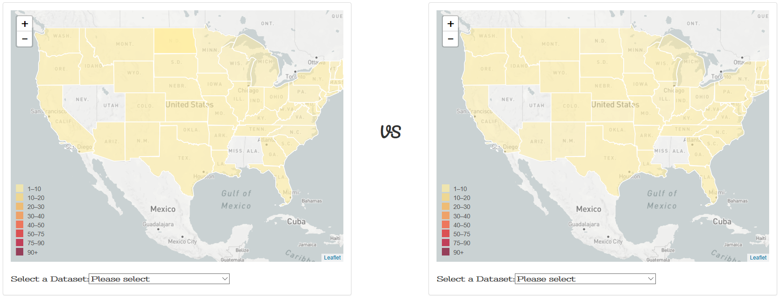

Initial Overview:

The intention is to develop a webpage using Flask, HTML/CSS, JavaScript, Database, Geomapping tools that will provide interactive visualizations to convey topics such as causes of flight delays in major airports, the airline accident/fatalities per state, and twitter analysis of what is considered as the best and worst airports in the country, and also the number of enplanement in major aiports to determine comparison and change statistics.